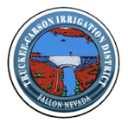
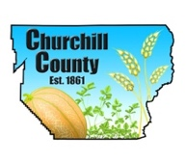

For Immediate Release

Media Contact:
Ty Whitaker, The Abbi Agency
ty@theabbiagency.com
775.722.3424

Construction finished at Lahontan Reservoir

FALLON, Nev. (March 31, 2017)— The concrete repair to the right discharge tunnel at Lahontan Dam has been completed, and officials are awaiting the test approval to open the outlet. It is expected to have approximately 2,400 cfs or more outflow from the dam by this weekend.
There will be a slight decrease in outflows Tuesday, April 3 while BOR conducts an inspection of the left tunnel. This should take about six hours and normal flows should return.
US 50 East of Fallon has been shut down and detours have been set up. This will be completed by April 6, 2017 or before and the highway reopens. Macari Lane will be closed for several months starting at the end of next week.
Progress on cleaning and lowering the diagonal drain, “The Big Dig,” is going according to plan and should be finished in about 3 weeks.
For frequent updates, visit ChurchillCounty.org, or FallonNevada.gov.
###

