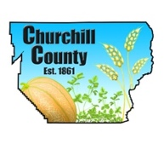

For Immediate Release

Media Contact:
Ty Whitaker, The Abbi Agency
ty@theabbiagency.com
775.722.3424

Re-pour of concrete at Lahontan Reservoir fortifies right outlet

FALLON, Nev. (March 28, 2017)— The concrete pour in the floor of the right discharge tube at Lahontan Dam has been completed and cure time is approximately three days. Flows from this tube will begin when the concrete meets specifications. These flows will be around 2800 cfs.
The work on the dome valve was completed and water releases began last night at approximately 8 p.m.
Work continues on the cleaning and widening of the diagonal drain project.
Local farmers completed a berm north of Carson Lake as an added safety feature for the homes in that area. The berm is approximately 1-1/2 miles long, 6 feet high and 14 feet wide. This was accomplished in two days with their own equipment and time.
Expect large flows in the Carson River toward the end of the week and is planned to continue for several months.

For frequent updates, visit ChurchillCounty.org, or FallonNevada.gov.
###

