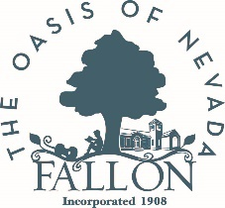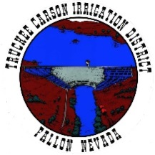

For immediate release: March 22, 2023

Town Hall to Discuss High-Water Mitigation Efforts Tomorrow, March 23
Public invited to attend from 3 to 4 p.m. at Rafter 3C Arena, 325 Sheckler Road

Fallon, NV – The public is invited to attend a town hall discussion with Churchill County, City of Fallon, Truckee Carson Irrigation District and Bureau of Reclamation officials regarding current high water mitigation efforts on Thursday, March 23 from 3 to 4 p.m. at the Rafter 3C Arena.

With record snowpack in the mountains, local officials have been working to relieve the potential for flooding in Churchill County and the City of Fallon by:

- Declaring an emergency on March 2, 2023 to gain access to resources available at the state and federal levels for mitigation efforts.
- Releasing water from Lahontan Reservoir over the past several weeks to lower the water level to make room for eventual snowmelt run-off.
- Opening the weir built in 2017 to allow more water to be released from Lahontan Reservoir.
- Making pre-filled sandbags available for residents to pick-up and use to protect private property.
- Cleaning out the Big Dig channel and culverts under Highways 95 and 50 to allow for more efficient water flow.
- Opening a High-Water Call Center, currently staffed weekdays from 8 a.m. to 5 p.m., for residents to make non-emergency inquiries regarding high water resources and services. The Call Center number is: (775)867-5923.

In addition to these efforts, Churchill County, the City of Fallon and the Truckee Carson Irrigation District have also been developing additional measures to prevent flooding within the Fallon community and outlying areas. As in 2017, these efforts are intended to manage water flow, protect life, safety, and property, and to minimize disruptions prior to the increase in water from snowmelt in the mountains. These measures will be further discussed at the town hall meeting.

For those unable to attend, a recording will be available at: https://www.youtube.com/@churchillcounty/community after the town hall.

Photo caption: Sandbags available for pick-up at 485 Miner’s Road (south of the Rafter 3C Arena) weekdays from 10 a.m. to noon and again from 12:30 to 2 p.m. and on Saturdays and Sundays from 9 a.m. to 2 p.m.

###

About Churchill County: Churchill County supports sustainable economic development and creating a diverse base of commercial, industrial, renewable energy, agricultural and military industries. We offer an outdoor lifestyle, cultural activities, a higher education campus, strong youth recreation and sports programs and a variety of annual community events making Churchill County an ideal place to live and work. Located 60 minutes east of Reno, Nev., Churchill County is investing in robust economic development now to address its future needs. For more information: www.churchillcountynv.gov

Media contact:
Anne McMillin, APR
Public Information Officer
Churchill County, Nevada
O: (775)423-2266
C: (775)666-8035
anne.mcmillin@churchillcountynv.gov
www.churchillcountynv.gov

