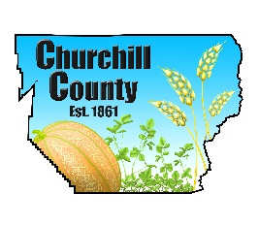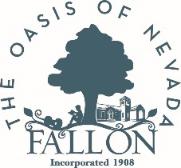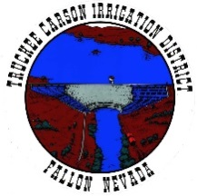

For immediate release: April 5, 2023

Local Youth to Fill, Deliver and Set-up Sandbags on April 22
Effort is part of Global Youth Day of Service

Fallon, NV – Local youth will fill, deliver and set-up sandbags for seniors (60+) and disabled people living on the Carson River on Saturday, April 22 from 9 a.m. to 1 p.m. as part of the Global Youth Day of Service.

Seniors and the disabled who live on the river and want help with sandbagging are asked to call the High-Water Call Center no later than April 20 to arrange for this free service. The number is (775)867-5923 and it is currently staffed weekdays from 8 a.m. to 5 p.m.

###

About Churchill County: Churchill County supports sustainable economic development and creating a diverse base of commercial, industrial, renewable energy, agricultural and military industries. We offer an outdoor lifestyle, cultural activities, a higher education campus, strong youth recreation and sports programs and a variety of annual community events making Churchill County an ideal place to live and work. Located 60 minutes east of Reno, Nev., Churchill County is investing in robust economic development now to address its future needs. For more information: www.churchillcountynv.gov

Media contact:
Anne McMillin, APR
Public Information Officer
Churchill County, Nevada
O: (775)423-2266
C: (775)666-8035
anne.mcmillin@churchillcountynv.gov
www.churchillcountynv.gov

