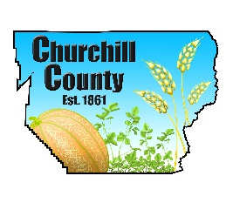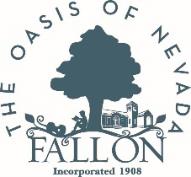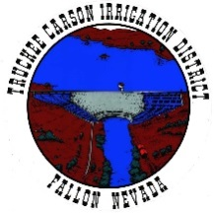

For immediate release: May 12, 2023

Update on Local High-Water Mitigation Projects
Efforts continue to safeguard the community
Fallon, NV – As the weather warms up, local officials continue high-water mitigation efforts to proactively address the potential for flooding in the coming months. The following projects are currently underway:
- Public water systems: City of Fallon and Churchill County are completing preparations to safeguard wastewater and water treatment facilities and urge residents and businesses in flood-prone areas to sandbag their cleanout vents to reduce the risk of compromised systems should a high-water event occur. Restaurants and businesses with grease interceptors should sandbag around those fixtures for the same reason.
- 2nd Weir: Under construction and on-track for completion around May 19 on the V-line canal adjacent to the 2017 weir. Water will flow through the new weir shortly after completion.
- Berm along Pasture Road: Completed. Built to increase capacity for water storage in the Carson Lake Pasture east of U.S. Highway 95 south of town.
- Sandbags: Free, pre-filled sandbags available for pick-up at 485 Miner’s Road, Fallon on Mondays from 1-4 p.m.
- Sandbag delivery requests: Contact the High-Water Call Center at 775-867-5923 and leave a message. Sandbag delivery available for those ages 60+ and the mobility-challenged who live on the Carson River. Calls will be returned weekdays from 11 a.m. to noon and 3 to 4 p.m. to schedule deliveries.
Photo caption: Cleanout vent that should be sandbagged if in a flood-prone area.

###

About Churchill County: Churchill County supports sustainable economic development and creating a diverse base of commercial, industrial, renewable energy, agricultural and military industries. We offer an outdoor lifestyle, cultural activities, a higher education campus, strong youth recreation and sports programs and a variety of annual community events making Churchill County an ideal place to live and work. Located 60 minutes east of Reno, Nev., Churchill County is investing in robust economic development now to address its future needs. For more information: www.churchillcountynv.gov

Media contact:
Anne McMillin, APR
Public Information Officer
Churchill County, Nevada
O: (775)423-2266
C: (775)666-8035
anne.mcmillin@churchillcountynv.gov
www.churchillcountynv.gov

